main communication modes for WBAN: intra-body communication and extra-body communication.

Intra-body communication refers to the information exchanged around the human body. It can be a sub-categorized as communication between biosensors, and communication between biosensors and the personal server (PS) as a PDA or smart phone.

Extra-body communication refers to the exchanging data between the PS and the external environment (hospital, doctor,..). we consider the PS employs a WLAN to reach an internet access point, and the access point use the Internet to communicate with final destination.

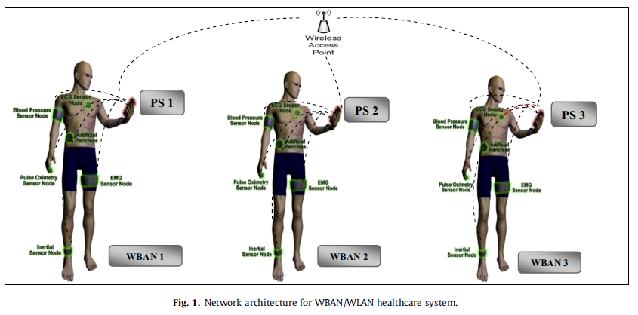

The challenge is the bridge WBAN and WLAN between IEEE 802.15.6 and IEEE 802.11e. in this paper we will study this bridge, and how PS bridge the WBANs traffic to WLAN networks and aggregate different WBAN frames into WLAN frame. We will also study how data packet classification, WBAN/WLAN bridging system with integration of mapping module and two scheduling mechanisms.

PFA ( priority Frame Aggregation) scheduler performs a scheduling algorithm mapping between WBAN and WLAN, and aggregate them into WLAN frame.

PF (priority frame) scheduler perform scheduling algorithm and mapping between WBAN and WLAN.